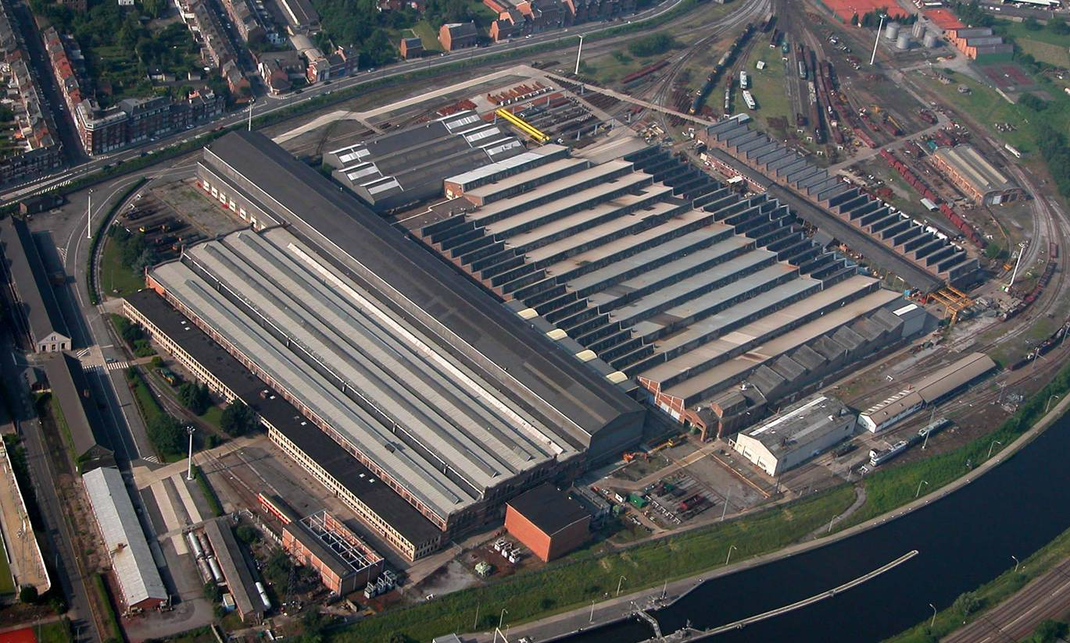

Salzinnes Central Workshop

Rue Fond des Bas Prés
5000 NAMUR

Handbook for External Firms

 | Name/s | Position/s
Checked by | I. Dechamps | Safety officer
Approved by | M. Bulteel | Director

Record of versions
ver. | Description of change | Requested by/Drawn up by | Date modified
00 | Document created | D. Bonnet  I. Dechamps  F. Nandrain | 09/2006
01 | Addition of for000147 to page 1 and alteration of introduction text following viewing of DVD in the reception area and pursuant to the Law of 03/06/2007 containing various employment provisions | D. Bonnet | 16/10/07
02 | -Addition to § 2.2: ban on road vehicles  -Drg No. changed to §4.6.4.  -Accident at work report sent to Health and Safety department within 15 days (p.18) | D. Bonnet  I. Dechamps  D. Namur | 07/12/07
03 | Amendment to 3.5. | I. Dechamps | 26/06/08

→ External firm: ________________________________

The following document is enclosed with this copy:

◻ FOR00147: acknowledgement of receipt of Handbook and undertaking by external firms (to be returned filled in)

1 Introduction 4
2 Accessing our Site 4
2.1 Registering at reception 4
2.2 Accessing the site 4
3 Compliance with Internal Regulations 5
3.1 Working Hours 5
3.2 Access to the parking area 5
3.3 Access to the restaurant and vending machines 5
3.4 Alcohol 6
3.5 Smoking 6
3.6 Hygiene 6
3.7 Good manners 6
4 Safety 7
4.1 Safety Requirements 7
4.2 Responsibility of the Contractor 7
4.3 Safety instructions and organisation of work 8
4.3.1 Obligation to provide information 8
4.3.2 Obligation to coordinate activities 9
4.3.3 Control Obligation (Art. 28 Ter 4) 9
4.3.4 Identification, access and authorisation to work 9
4.4 Obligations, prohibitions, and descriptions of the risks specific to AC Salzinnes 10
4.4.1 Instructions 10
4.4.2 Risks specific to AC SALZINNES 11
4.5 Instructions regarding the equipment and products used by contractors 13
4.5.1 Deployment of hazardous preparations and products by contractors and the use of these products and preparations by their personnel 13
4.5.2 Tools, machines, auxiliary equipment (scaffolding, ladders, etc.), vehicles, lifting equipment and electrical equipment brought on site by contractors and used by their personnel 14
4.5.3 Gas bottles 15
4.5.4 AC Salzinnes equipment and materials used by contractors 15
4.5.5 Personal protection equipment 16
4.5.6 Collective protection equipment 16
4.6 Practical instructions to be followed in the event of an accident at work 17
4.6.1 First aid posts. 17
4.6.2 Minor accidents 17
4.6.3 Serious accidents 18
4.6.4 Emergencies 18
5 Environment 20
5.1 Waste 20
5.1.1 Domestic waste 20
5.1.2 Hazardous waste 22
5.2 Pollution Prevention 23

Introduction
You will be visiting our workshop for business reasons (work, consultancy, etc.).

The purpose of this document, pursuant to current employment legislation and the Law of 04/08/96 (Chapter IV, Articles 8, 9, and 10; Chapter V, Articles 26 to 29 inclusive) (latest version), is to enable you to provide your staff and subcontractors with the general instructions and other useful information needed to ensure that your work at the SALZINNES Central Workshop is carried out safely, while respecting the environment and abiding by the internal regulations.

Compliance with the internal regulations and safety and environmental rules is an essential condition for the execution of the contract. These safety regulations supplement the details given in the tender specifications and/or business contracts involved.
By virtue of the above, you are legally required to pass on the contents of this document to your employees working on our site and hand over a full copy of the document to all your subcontractors so that they can do the same.
Your own employees and those of your subcontractors will only be allowed to access the site after
- Watching a welcome DVD
- Passing the DVD comprehension test (evaluation). The minimum pass mark is 7/10!

Our workshop is ISO 9001, ISO 14001 and OHSAS 18001 certified, and practices 5S continuous improvement. We would ask you to respect the procedures set up by the personnel.

Accessing our site

Registering at reception
Only people and vehicles whose presence is required by contract are allowed to access SALZINNES Central Workshop, and then only for the time strictly necessary for the contract work to be done.

When you have registered at reception, the porter will issue you with a permit to enter our premises. You are asked to comply with the badge or registration formalities as requested before entering.

Accessing the site

You will only have access to the areas where you are required to work. Please comply with this restriction by following the instructions of the person who admits you, or for whom you are doing a job, to the letter.
No road vehicles are allowed to enter or park in the workshop buildings without written permission from the Project Manager.
The conditions of access to the grounds or worksites will be defined on a case-by-case basis.
The Belgian highway code is applicable, as are local prohibitory, mandatory, and give way signs. The speed limit on site is 10 km/h. Rail traffic takes priority.
Supplies can only be dropped off after specific authorisation has been given and the place to be used for this purpose has been designated by a SALZINNES Central Workshop representative.

If you are required to enter the workshop buildings on foot, you must follow the designated routes and wear safety footwear (if such footwear is specified for your job).

No actions liable to cause harm to oneself or others must be undertaken, and any such actions will lead to immediate exclusion from our premises.

Compliance with Internal Regulations

Working Hours
Working hours, i.e. the hours when the workshop is open, are from 07.05 to 16.15. You must comply with the times agreed upon with the person who admits you. If you need to work in our workshops at other times, you can only do so subject to their approval and under their responsibility.

Access to the parking area
The parking area is intended for staff only. However, spaces are reserved for visitors opposite the entrance. If you are given permission to take your vehicle into the parking area, please use one of these spaces or follow the porter’s instructions. In all cases, please respect the signs and parking spaces and make sure you do not encroach on the space required by locomotives or articulated lorries.

Access to the restaurant and vending machines

The staff lunch break is from 11.35 to 12.05, and you are asked to comply with this break. Only staff and company restaurants department permit holders may use the restaurant. Training monitors, however, may accompany their trainee railway workers to the restaurant. Guests of officials may also accompany their hosts.

If you would like to eat during the lunch break, you can ask the person who admits you for access to a canteen, where you can eat your meal.

Vending machines are available to staff at several locations in the workshop. Feel free to make use of these, but please treat the equipment correctly and dispose of your cans in the designated plastic/metal/cardboard recycling bins.

Alcohol

It is strictly prohibited to bring alcoholic drinks (beer, wine, aperitifs, spirits etc.) or drugs into the central workshop or to consume them on site. Anyone found to be in breach of this directive will be expelled from the workshop immediately.
Anyone showing symptoms of being under the influence of such substances will not be granted access the sites.

Smoking
Smoking is banned in all areas of the workshop buildings, including corridors and toilets.

Smoking is permitted outside, but this is not to be construed as meaning that it can be used as an excuse to take an obvious break during working hours. Cigarette ends are not to be thrown on the ground. They must be stubbed out in the ashtrays made available outside the buildings. Anyone found to be in breach of anti-smoking legislation will immediately be expelled from the workshop on their second offence.

Hygiene
The basic rules of hygiene must be complied with.

Contractors must keep the site clean and tidy.

Good manners

All members of the personnel of this workshop are to be treated politely and their work respected.

Safety

Safety Requirements

Contractors must strictly comply with the following instructions and specifications:

- All laws and regulations regarding safety (including the R.G.P.T, the R.G.I.E, and the CODE DU BIEN-ETRE).
- The general safety instructions contained in the booklet “Working and travelling safely with the SNCB” (supplied on request by the safety officer)
- The specific safety instructions in force at SALZINNES Central Workshop

Before starting work, contractors must make a declaration that they have examined and taken in the safety instructions detailed or mentioned in these general safety regulations and must undertake to comply with them and ensure that they are complied with by their employees and subcontractors.

Responsibility of the Contractor

- Contractors are responsible for the safety of the work entrusted to them. They must take all necessary measures for this purpose.

- Contractors must confirm that their workers have sufficient training in the tasks entrusted to them and that they have access to, and use, the working equipment and the required protective equipment intended for common and individual usage.

- Contractors are responsible for damage caused by their personnel and subcontractors. They must defend SALZINNES Central Workshop against any third party recourse in this respect. Contractors must take out adequate insurance to cover their liability.

- Contractors must inform SALZINNES Central Workshop immediately and then in writing as quickly as possible of any circumstances preventing them from continuing their work safely.

- Any supervision by a SALZINNES Central Workshop employee will relate solely to the execution of the contract as such and will not constitute a transfer of authority or liability. However, SALZINNES Central Workshop reserves the right to inspect the work, forbid the usage of unreliable materials, equipment and/or working methods, and have the work stopped until the cause of the stoppage has been eliminated. The same applies if AC Salzinnes considers that the way in which the work is carried out is in breach of relevant rules on health, safety, and environmental protection. Neither contractors nor their agents or subcontractors will be entitled to any compensation if they are responsible for an unsafe situation arising.

- In all cases, contractors must advise SALZINNES Central Workshop of the involvement of any subcontractors before starting the work. If the work requires the unexpected assistance of a subcontractor, SALZINNES Central Workshop must be notified of this before this subcontractor starts work.

- Neither the general safety regulations, nor the right to carry out the inspections provided for therein, nor SALZINNES Central Workshop’s right to stop the work have any effect on the specific liability of contractors.

- Similarly, the directives and advice given by SALZINNES Central Workshop to contractors regarding the application of the various instructions will in no circumstances exempt contractors from their own responsibility.

- Individuals who do not comply with all of the requirements of these regulations will be removed from the sites.

Safety instructions and organisation of work

Obligation to provide information

As from the signature of the contract and in all cases before starting work:

- Contractors must familiarise themselves with the information given by SALZINNES Central Workshop regarding the specific site risks, the specific equipment of SALZINNES Central Workshop, the premises, the prevention and protection measures in force on the site, and the emergency procedures (alarms, emergency exits, fire-fighting, evacuation of personnel, etc.).

- If a contractor’s work involves specific risks, this must be notified to SALZINNES Central Workshop and any other contractors on site so that they can take the necessary steps to protect their personnel.

- To this end, the contractor must visit the site, preferably accompanied by its safety officer, to examine the places where the work is to be carried out, look into the working conditions and take all necessary safety measures.

- In particular, contractors must familiarise themselves with the safety instructions listed in 4.4. to 4.6. below.

Obligation to coordinate activities

- One or more coordination meetings will be held at the initiative of SALZINNES Central Workshop (the technical officer in charge of the contract) or the contractor in order to ensure good coordination of safety measures. In all cases, a meeting attended by a representative of the health and safety department will be held before work starts.
All safety instructions and decisions taken at these meetings will come into force immediately.

- Contractors must take responsibility for organising the safety of both their own work and that of their representatives and subcontractors. They must ensure good coordination and supervise all personnel doing contract work on their behalf.

- When the personnel of SALZINNES Central Workshop and the contractor are working simultaneously on the site, the safety measures to be implemented will be determined by mutual agreement and in accordance with the safety instructions in force at SALZINNES Central Workshop. The contractor and SALZINNES Central Workshop (the technical officer in charge of the contract) will make arrangements regarding health, safety and hygiene jointly, after consulting the health and safety department, and will ensure that they are applied. Their work will be coordinated in advance.

Control Obligation (Art. 28 Ter 4)

- Before granting access to the site, SALZINNES Central Workshop may check that all contractors’ and subcontractors’ workers are thoroughly versed in the special safety rules and instructions. No compensation will be paid if a worker is refused access.

Identification, access and permission to work

Identification of contractors and workers

Before starting work, every contractor must submit a document, duly signed, containing the identification data of the contractor and its officers (e.g. safety officer or occupational health department).

If subcontractors are employed, this document must be filled in for each subcontractor, who must also sign it.

Access

See page 4

Obligations, prohibitions, and descriptions of the risks specific to AC Salzinnes

Instructions:
All external workers must:
- Do everything they can to safeguard their own health and safety as well as that of the other workers
- Study and comply with the safety instructions in force on the site
- Use the machinery, equipment, tools, hazardous substances, transport equipment and other vehicles as well as common protective equipment correctly
- Wear and use personal protection equipment (helmet, safety boots, safety vest, etc.) correctly
- Notify the site foreman immediately of any working situations presenting a serious and immediate danger
- Remove and take full responsibility for the waste they produce on site (waste materials, packaging, old parts, drained oil, etc). The burning of such waste is forbidden (see waste management).
- Take specific steps to prevent accidental spillages onto the ground (see page 24)
- Cooperate with SALZINNES Central Workshop personnel to ensure that all tasks or requirements involved in the well-being of the workers are complied with
- Special safety devices must not be taken out of service, changed, or moved arbitrarily.
- Any use of hazardous products must be notified to the AC Salzinnes environmental officer and/or the safety officer beforehand, and a copy of the product’s safety and technical data sheets must be submitted to them before the work starts. Contractors are responsible for the storage of these products during the work.
- In the case of hot work (welding, cutting, brazing, pickling, burning of paint or varnish, asphalting, defrosting, etc.), a fire permit must be drawn up by the department requesting the work and submitted to the safety officer for approval prior to the work being carried out. A copy of the fire permit will be handed over to the operative, who will be required to comply with the instructions it contains.

Before starting work, locate all available fire-fighting equipment (extinguishers, hoses, etc.)
A suitable extinguisher must always be kept close to hand for this type of work.
A check will be carried out after the work.

Personnel of external contractors must stay within within their working areas.

Risks specific to SALZINNES Central Workshop

Rail traffic

There are rail tracks both inside and outside the buildings. All locomotives have absolute priority over pedestrians, cyclists, and automobiles.
You are therefore asked:
- to use only the marked routes to move about on our site
- to be vigilant when approaching a rail track
- to give way to any locomotive
- to stay as far as possible outside the danger area, i.e. more than 1.5m from the track
- If you have to work in the danger area (<1.5 m), advise SALZINNES Central Workshop (technical officer in charge of the contract) so that adequate signs can be put up. Wear warning clothing.

Travelling cranes and jibs

Our workshops are equipped with many travelling cranes and jibs.
The following are strictly forbidden:
  - standing under the load of a travelling crane; when it approaches, you must leave its path
  - using any of this lifting equipment personally unless specially authorised to do so by the order form
  - travelling on these cranes or on their travelling path, other than with special permission

The travelling cranes must only be moved (for working purposes) by skilled personnel from the Salzinnes workshop, at times agreed beforehand.

Electrical plant

Our electrical plant involves many overhead lines. These may have faulty insulation. Furthermore, some travelling cranes are powered via bare wires.

You are asked to take care near any electrical line or installation, and in particular when positioning and using ladders or aerial platforms, due to the possible presence of bare wires.

No overhead work can be carried out on or near electrical equipment without prior permission from the supervisor of the general electrical department.

Working on a live plant or live electrical equipment is strictly forbidden.
A track outside the workshop has a catenary supplied under 3 KV dc or 25 KV ac.
- It must always be considered as “live”.
- Stay at least 3 metres away from the catenary.
- Never aim a jet of water towards the catenary.
- Do not carry any very long items along this track vertically.
- If there is any possibility of coming into contact with the catenary or coming within 3 metres of it when working, a work permit must be obtained beforehand and the power cut off.

Flammable products

Certain locations in the central workshop contain flammable products which may be found in drums, cleaning baths or in the atmosphere (spray booths). This means that:
- No hot work is permitted anywhere on our site without a fire permit issued as described above prior to the work being done.
- A suitable extinguisher must always be kept close to hand for this type of work.

Ducting

Special care must be taken to protect ducts containing:
- compressed air
- oxygen
- natural gas
- diesel

Care must be taken with overhead ducting which may cross traffic routes outside – vehicles must not be more than 4 m high.

Crane runways

Crane runways must be protected from splashes and impacts.

Instructions regarding the equipment and products used by contractors

Deployment of hazardous preparations and products by contractors and the use of these products and preparations by their personnel

- When the work requires the use of hazardous preparations and/or substances, contractors must strictly comply with the provisions regarding the safety and protection of workers.

- In such cases, they must take the greatest care to choose suitable, strong containers whose seals will remain intact during handling or on impact, and must ensure that they are correctly labelled and stored. Correct labelling must be such as to permit anyone on the site to identify the product quickly and to be aware of the risks and the obligatory or recommended safety measures.

- Only quantities which are strictly necessary for the work or for a specific period may be stored on site. Contractors must supply lists of the products used on the site along with their health and safety data sheets before the work starts.

- Flammable liquids such as paint and solvents must be stored in sealed and labelled metal containers in a well-ventilated area where there is no fire risk in normal conditions.

- Contractors are responsible for the products used in their work, as well as their transport and removal, regardless of their place of origin, including any waste produced due to the use of these products.

Subcontractors must provide complete lists of the products used in our workshop in the following format:

Product Name | Use | Packaging | Quantity stored on our site | MSDS
 |  |  |  | yes / no

The safety data sheets for all products used are to be forwarded to the safety officer and the environmental manager of the Central Workshop.
These safety data sheets must contain the 16 entries detailed in Appendix V to the Royal Decree of 17th July 2002 governing the classification, packaging and labelling of hazardous preparations with a view to their being offered for sale or their use.

Tools, machines, auxiliary equipment (scaffolding, ladders, etc.), vehicles, lifting equipment and electrical equipment brought on site by contractors and used by their personnel

- Only working equipment and protective equipment for personal and collective use meeting the relevant safety requirements of the job may be used, in view of the risks of the working environment (e.g. water, impact, heat, cold, dust, explosive atmospheres, etc.). This equipment must be suitable for the users, in good working condition, and properly maintained.

- Valid certificates or evidence of inspection must always accompany the equipment in question in such a way as to be available at all times to SALZINNES Central Workshop, the approved organisation, and the official in charge of supervision.

- Inspection certificates are required in particular for the following machines, machine tools and equipment: cranes, hoists, anchoring equipment, lifting equipment, electric arc-welding equipment, autogenous welding equipment, electro-generating sets, gas expansion devices, scaffolding, ladders and mobile platform lifts.

- Cranes and scaffolding set up by contractors must be designed in accordance with health and safety requirements. They must be inspected by a qualified person. Lifting equipment must be installed and used in compliance with health and safety requirements. The certificate from the approved organisation must be kept on site.

- Independently of the inspections required by Law, SALZINNES Central Workshop can always order a check on equipment which appears to be of dubious quality or inadequate safety, or carry out the inspection itself. After inspection, any rejected equipment must be removed from the site and replaced at the owner’s expense.

- All equipment and tools permitted on site must be clearly identified for the purposes of the above inspections.

- All persons in positions responsible for safety (drivers of vehicles with engines, cranes, lifting equipment, etc.) pursuant to the definition in the legislation on well-being at work must submit medical reports issued by an occupational physician stating that they are medically fit to use the machine in question. Machinery, equipment (in particular mobile platform lifts) and vehicles may only be put into use and operated by these qualified persons.

- Equipment, vehicles and raw materials may only be used during normal working hours unless specific permission is obtained in advance.

- The organisation of the worksite, including the storage of plants, equipment and machinery, must not obstruct the operation of the site or the free movement of vehicles and persons. Equipment must only be stored at the places indicated by a responsible person appointed by SALZINNES Central Workshop.

- At the end of the working day, all the contractor’s machinery and equipment must be protected against any abusive use. Loose items must be removed from the worksite or firmly secured. In all situations, contractors must take all the necessary precautionary steps to prevent hazardous situations in the event of deteriorating atmospheric conditions (e.g. storms, lightning, etc.).

Gas bottles

Gas bottles must always be handled with the greatest care (store bottles vertically, always fasten with a chain, cap screwed on).

AC Salzinnes equipment and materials used by contractors

SALZINNES Central Workshop’s equipment may only be used subject to agreement by the site manager and after receiving the relevant instructions on its use.
It must be returned, either after use or once the work is completed (if loaned for the entire contractual period), in the same condition as when it was received. Equipment which is not returned once work is completed or which has been damaged must be replaced or repaired at the contractor’s expense. In addition, SALZINNES Central Workshop reserves the right to ask contractors to sign a receipt for any equipment loaned. All thefts will be prosecuted.

Individual protective equipment

Contractors must supply their personnel with the necessary personal protection equipment and working garments.
They must ensure that their workers use them and are trained in their use whenever the time, place or circumstances make them obligatory.

Collective protective equipment

The use of common protective equipment such as safety railings, safety nets, the marking out of trenches and holes in the ground, and the protection of machine tools is obligatory whenever required for the safety of those on site.

Contractors must provide the necessary signs and barriers whenever work is being carried out which may endanger others or may constitute an obstacle, such as excavations, work above traffic areas, welding work, and the creation of obstacles.

If it is technically impossible to provide common protective equipment, the contractor must provide additional personal protective equipment (e.g. approved fall prevention equipment).

Any openings made in the ground or walls must be closed up immediately. If this is not possible, the contractor must install a secure barrier around the openings. Such barriers must not be removed until the work is complete.

Contractors may not remove permanent protection in order to carry out work unless authorised to do so. If it is absolutely necessary to do so, contractors must set up temporary protections by agreement with the responsible person appointed by SALZINNES Central Workshop. For example, they must ensure that sturdy guardrails are installed around openings as well as areas to which entry might be hazardous. These areas must be adequately lit and furnished with the necessary signage and safety information in accordance with current legislation on this matter. As soon as the work is complete, all protections, barriers, etc. must be returned to their original state by the contractor in question.

Contractors must notify AC Salzinnes of any hazardous obstacles present on the site.

Practical instructions to be followed in the event of an accident at work

Any accidents at work must be notified immediately and confirmed in writing to the SALZINNES Central Workshop site manager and the health and safety department. Accident reports must be sent to the Salzinnes Workshop health and safety department within 15 days.

Safety Officer: I. Dechamps: 081/25 20 12
Asst. Safety Officers: P. Renard: 081/ 25 20 79
D. Namur: 081/ 25 56 70

 SNCB Nurse:
Extensions: 2666 or 2017 or 2029
External lines: 081/25.26.66 or 081/25.20.17 or 081/25.20.29

First aid posts

There are first aid posts in all the buildings. They are identified by icons (a white cross on a green background) and first aiders are available to provide first aid there on weekdays from 07:00 to 15:30, except during the period when the workshop is closed.
Failing this, the infirmary is located in the first building to the right from the main entrance (: 081/25.26.66)

Minor accidents

WHAT TO DO IN THE EVENT OF AN ACCIDENT
- Eliminate any remaining hazards.
- Comfort the victim.
- Have a first aider provide the victim with all possible care.
- If necessary, organise appropriate rescue procedures.
- Investigate the circumstances of the accident.

Serious accidents

- Before taking any other action: Eliminate any remaining hazards.
- Cut off the electricity.
- Remove or stabilise unstable objects, and so on.

- Inform the site management and internal first aid services (nurse), specifying the time and circumstances of the accident.  Nurse 081/25 26 66

- If a doctor has to be called, or a 100 call made (medical emergencies and fire brigade), the nurse will be in charge of calling the emergency services and will guide them to where the injured person is located.

Content of message:

Name of caller:

Identification of site:
Atelier SNCB
Rue Fond des Bas Prés
5000 Namur - Salzinnes

Location of accident:
The location of the accident will be indicated using the access plan.
The emergency services will arrive through the front entrance.

nombre de blessés + nature des blessures:

Someone will be designated to meet, inform and guide the emergency crew.

Emergencies

Any fire, accident, incident or other emergency must be notified to the site management immediately.

If the alarms go off, the contractors’ personnel must comply with local instructions (see internal emergency plan).

Evacuation drills are possible. These will be applicable to everyone on site, with no exceptions.

The SALZINNES Central Workshop site manager or supervisor must always be informed of the use of extinguishers.
Emergency equipment, such as extinguishers, must never be moved except in the event of an emergency. This equipment must be accessible at all times.

IN THE EVENT OF FIRE: (See the AC Salzinnes “Internal Emergency Plan”)

- Press the fire alarm push-button. This will alert the area’s fire safety officers directly.

- Follow the orders given by the Fire Safety officers and/or the Fire Brigade.

- If a fire has got out of control or can no longer be contained: Think of your own life and save yourself, but always make sure the competent services have been alerted.

STEPS TO BE TAKEN IN THE EVENT OF AN ALARM – EVACUATINg WORKERS

The workshop is equipped with an alarm system with sirens which produce a continuous sound.
Regardless of the cause, the premises must be evacuated as quickly as possible (without using the lifts or goods lifts) and all staff must proceed quickly to the nearest assembly points (see Plan S-1-81-0005/5 attached). Once you arrive at the assembly point, make yourself known and comply with the instructions you are given.

Environment

Waste
There are two possibilities. External firms may either remove their own waste, including domestic waste, or participate in the waste sorting policy specific to our workshop. Our sorting guide can be supplied on request.
Domestic and other waste which has not been produced on our site must not be disposed of here.

Domestic waste
Domestic waste is to be sorted in accordance with our sorting guide.
No fly tipping!

Paper and cardboard

Paper and cardboard which have not been soiled by hazardous products are to be discarded either in yellow bins or in marked metal boxes intended for paper and cardboard.
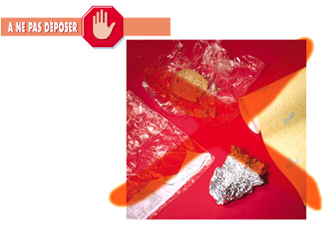
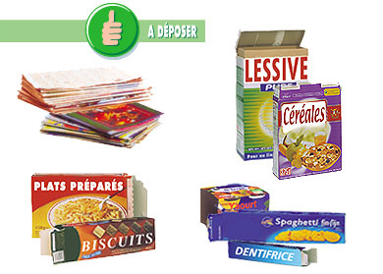
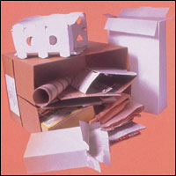

Discard here Do not discard here
AUTHORISED | COMMENTS | PROHIBITED
Cardboard boxes  Paper bags  Magazines and newspapers Telephone directories  Advertising leaflets  Computer paper  Writing paper and machine paper | Remove the plastic film from newspapers, magazines and leaflets | Greasy or soiled paper/cardboard  Cellophane  Plastic film  Wallpaper  Aluminium foil

Plastic/Metal/Cardboard
Plastic, metal and cardboard are to be discarded in the blue bins.
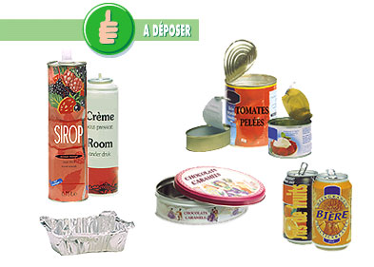
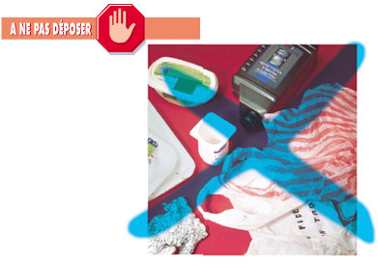
Completely empty with no food scraps

M

Discard here Do not discard here
Drink cans  Jar lids | Jars and pots (yoghurt, butter, margarine, coffee cups, etc.)
Food tins | Plastic bags
Cosmetic or food aerosol sprays | Polystyrene*
Aluminium trays and pots | Aluminium sheets
 | Hazardous product sprays
 | *Polystyrene is selectively recycled at the recycling site
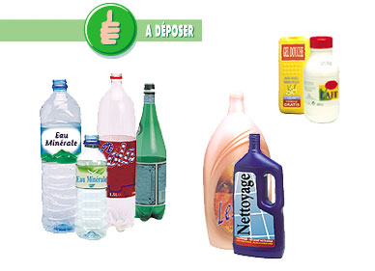
Completely empty with no food scraps

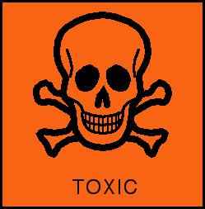
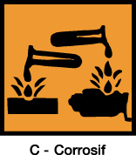

P


Discard here Do not discard here
Crushed water, lemonade, and fruit juice bottles with their caps | Packaging which has contained toxic and/or corrosive products
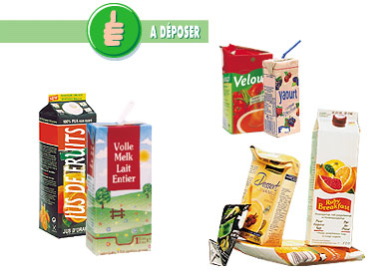
Completely empty with no food scraps

C

Discard here
Drink cartons which have contained liquids (fruit juice, milk, etc.) | Gloves

Hazardous waste

The definition of hazardous waste in the Walloon waste catalogue is very complex. We define hazardous waste as packaging which is soiled or has contained a product characterised by the following hazard warning symbols:

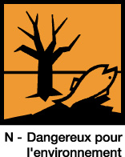



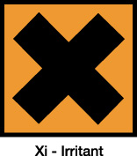
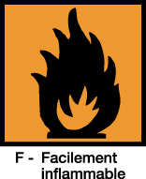

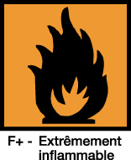
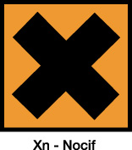


C – Corrosive E – Explosive O – Combustive N – Environmental Hazard Xi – Irritant Xn – Noxious F – Easily Flammable F+ - Highly Flammable T – Toxic Tx – Very Toxic
Soiled cloths and paper are to be placed in the red bags.
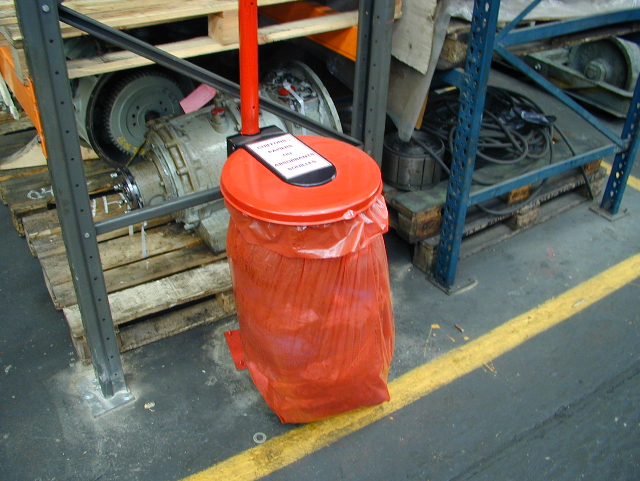

Hazardous waste produced by external firms in our workshop will be removed at their expense and disposed of under their responsibility. Approved waste elimination certificates will be supplied.

However, hazardous waste produced in small quantities (paint pots, spray cans, etc.) are to be deposited at the workshop recycling site when finished with. This site is located in building 16.8 (see map).

Pollution Prevention
Take steps to prevent accidental spillages onto the ground.

In the event of an accidental spillage, immediate steps must be taken to prevent the hazardous products from running into the drainage system or seeping into the ground.

During work where there is a risk of polluting the ground or spilling hazardous products into the drainage system, external firms must be equipped with anti-pollution resources (absorbent rolls, etc.)

Any cleanup of pollution caused by the ill-will of an external contractor will be the contractor’s own responsibility.

If pollution occurs, alert the environmental manager as quickly as possible (081/25 20 04 or 081/25 56 66)

HAZARDOUS PRODUCTS MUST NOT BE DISPOSED OF INTO THE DRAINAGE SYSTEM OR IN THE ENVIRONMENT

General Health and Safety Regulations
General Industrial Safety Regulations
Legislation on well-being at work

